**AAA COLLEGE OF ENGINEERING AND TECHNOLOGY**

|  |  |  |  |  |  |  |  |  |  |  |  |  |  |
| --- | --- | --- | --- | --- | --- | --- | --- | --- | --- | --- | --- | --- | --- |
|  | **Department of Electronics and Communication Engineering**  **Smart Farmer-IOT Enabled Smart Farming Application**  **IBM NALAIYATHIRAN**  **Technical Stack**   |  |  | | --- | --- | | **TITLE** | **Smart Farmer-IOT Enabled Smart Farming Application** | | **DOMAIN NAME** | INTERNET OF THINGS | | **TEAM ID** | PNT2022TMID51214 | | **LEADER NAME** | G.KARTHIKA | | **TEAM MEMBER NAME** | T.ANUSHA  C.ARCHANADEVI  M.KAVIYA | | **MENTOR NAME** | G.JAYAHARI PRABHU | |

The Deliverable shall

Include the architectural diagramas below and the information as per the table1&table2

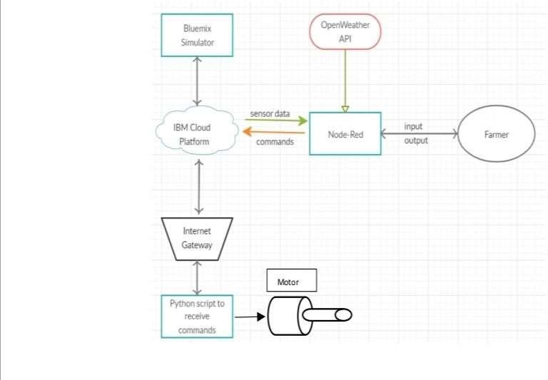

Guidelines:

1. Includealltheprocesses(Asanapplicationlogic/TechnologyBlock)
2. Provideinfrastructuraldemarcation(Local/Cloud)
3. Indicateexternalinterfaces(thirdpartyAPI’setc.)
4. IndicateDataStoragecomponents/services
5. Indicateinterfacetomachinelearningmodels(ifapplicable)

* The different soil parameters temperature, soil moistures and then humidity are sensed using different sensors and obtained value is stored in the IBM cloud.
* Arduino UNO is used as a processing Unit that process the data obtained from the sensors and whether data from the weather API.
* NODE-RED is used as a programming tool to write the hardware, software, and APIs. The MQTT protocol is followed for the communication.
* All the collected data are provided to the user through a mobile application that was developed using the MIT app inventor. The user could decide through an app, weather to water the crop ornot depending upon the sensor values. By using the app, they can remotely operate the motor switch.

**Table-1:**

**Components & Technologies:**

|  |  |  |  |
| --- | --- | --- | --- |
| **S.NO** | **Component** | **Description** | **Technology** |
| 1. | User Interface | How user interacts with application e.g.WebUI, MobileApp. | HTML, CSS, JavaScript/Angular Js/ReactJsetc. |
| 2. | ApplicationLogic-1 | Logic for a process in the application | Python |
| 3. | ApplicationLogic-2 | Logic for a process in the application | IBM Watson IOT service |
| 4. | ApplicationLogic-3 | Logic for a process in the application | IBM Watson Assistant |
| 5. | Database | Data Type, Configurations etc. | My SQL, No SQL, etc. |
| 6. | Cloud Database | Data base Service on Cloud | IBM Cloud |
| 7. | File Storage | File storage requirements | IBM Block Storage or Other  Storage Service or Local File system |
| 8. | ExternalAPI-1 | Purpose of External API used in the application | IBM Weather API ,etc. |
|  |  |  |  |
| 9. | Machine Learning Model | Purpose of Machine Learning Model | Object Recognition Model, etc. |
| 10. | Infrastructure(Server/Cloud) | ApplicationDeploymentonLocalSystem/CloudLocalServerConfiguration:  Cloud Server Configuration: | Local, Cloud Foundry, Kubernetes ,etc. |

**Table-2:**

**ApplicationCharacteristics:**

|  |  |  |  |
| --- | --- | --- | --- |
| **S.No** | **Characteristics** | **Description** | **Technology** |
| 1. | Open-SourceFrameworks | Listtheopen-sourceframeworksused | Technology of Open sourceframework |
| 2. | SecurityImplementations | Sensitiveandprivatedatamustbeprotectedfromtheir production until the decision-making andstorageStages. | e.g. Node-Red ,Open weather App API,MIT App Inventor,etc. |
| 3. | ScalableArchitecture | Scalability is a major concern for IoT platforms. Ithas beenshownthatdifferentarchitecturalchoices ofIoT platforms affect system scalabilityand that automaticreal time decision-making isfeasibleinanEnvironmentcomposedofdozensofthousand. | Technology used |
| 4. | Availability | Automaticadjustmentoffarmingequipmentmadepossible by linking information like crops/weatherand equipment to auto-adjust temperature,humidity,etc. | Technology used |
| 5. | Performance | Theideaofimplementingintegratedsensorswithsensing soil and environmental or ambientparameters  infarmingwillbemoreefficientforoverallmonitoring. | Technology used |